Snowflake schema

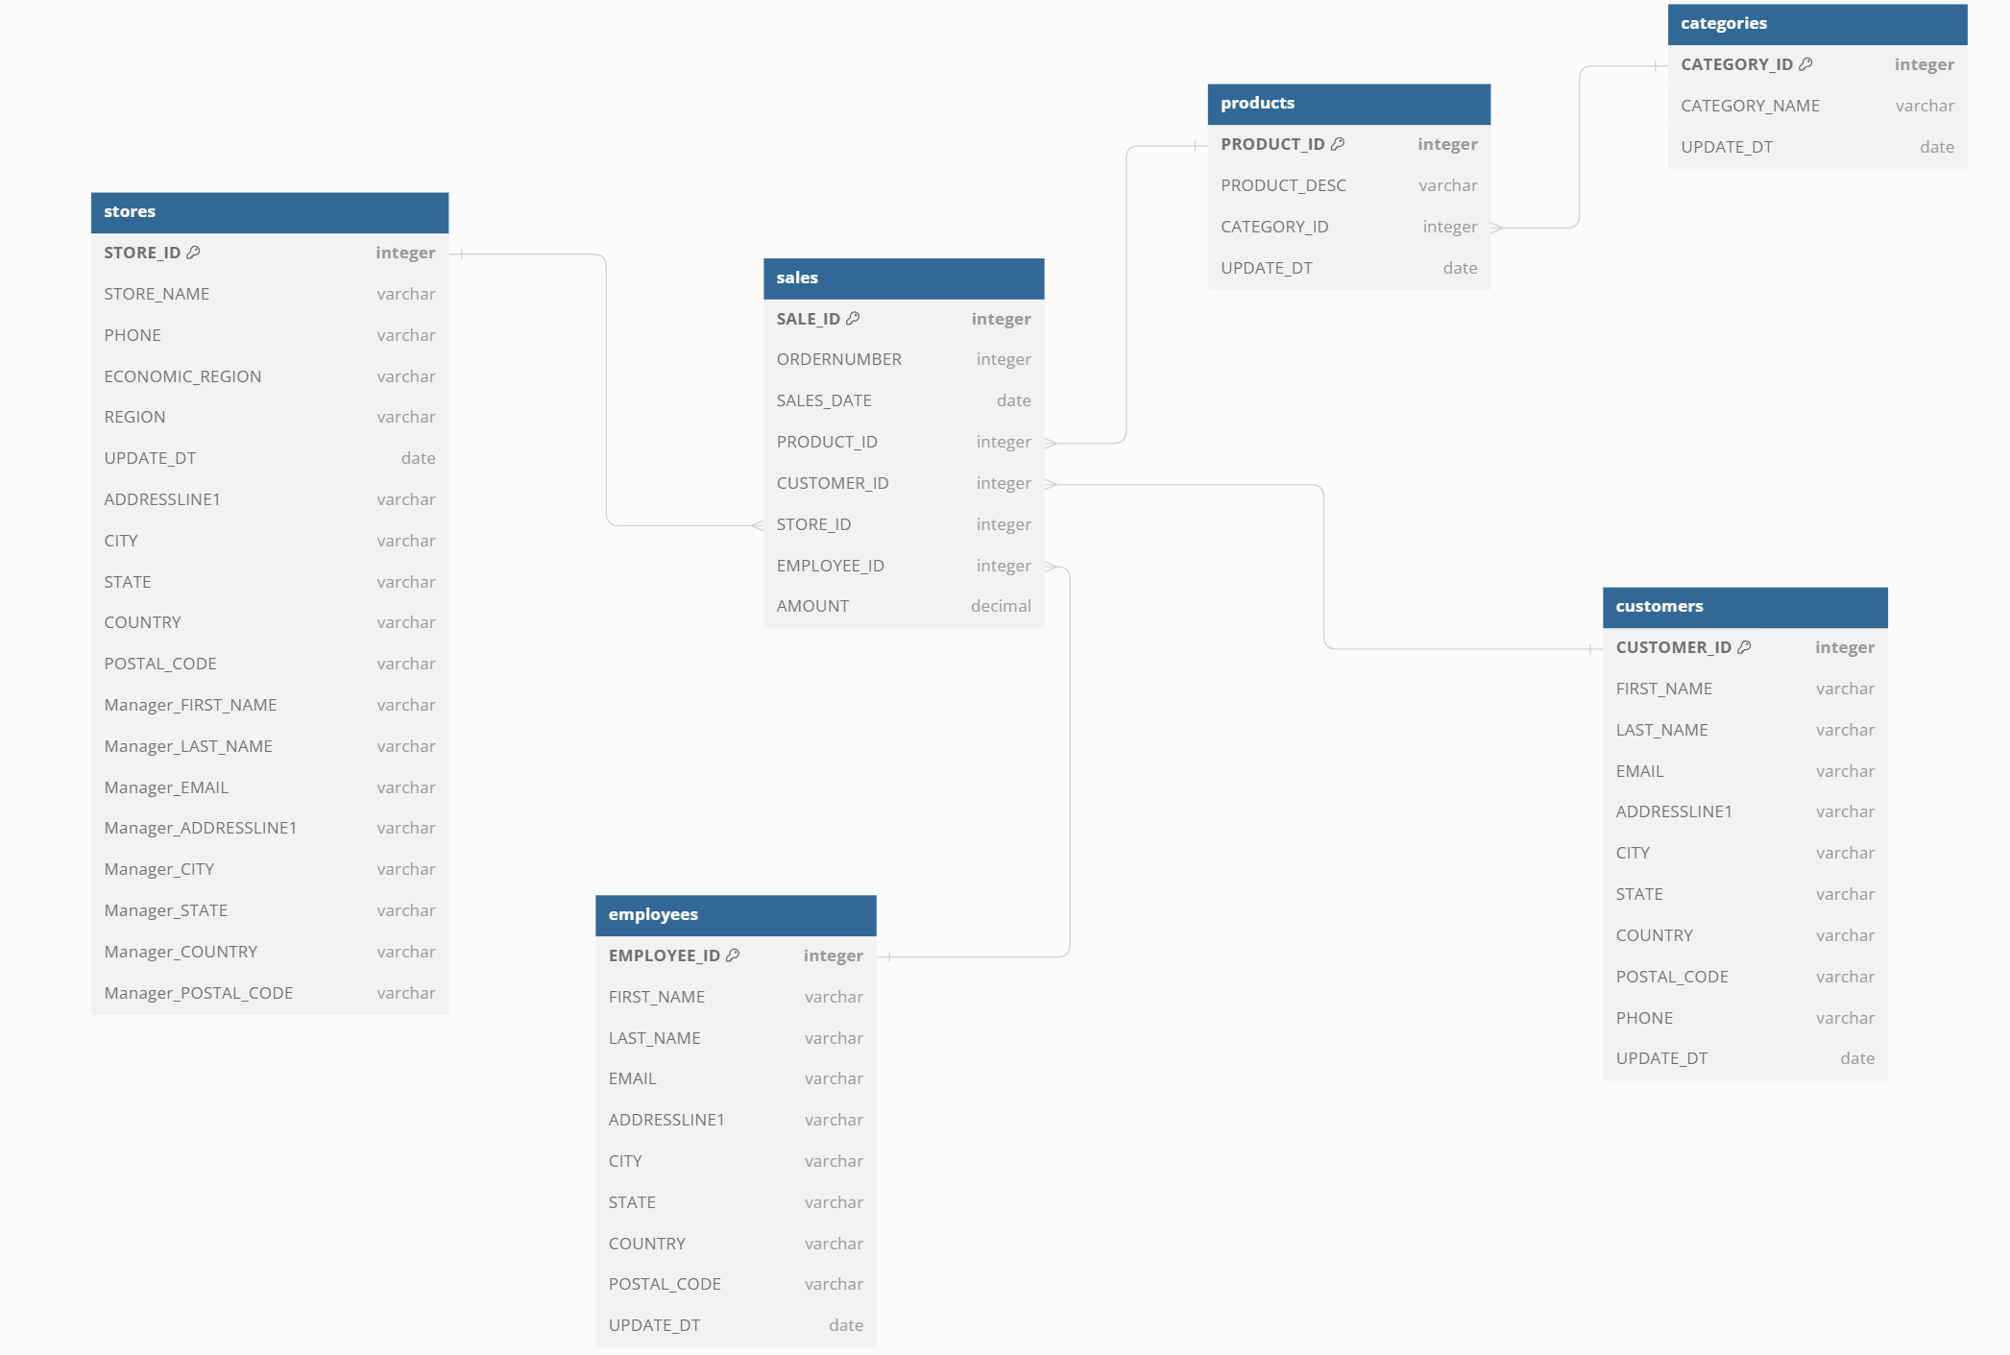

I did not change anything here, except I divided product dimension and created one additional table for subcategory. I feel like if I wanted to normalized other dimensions that would means adding address tables to all of it. Like store table would have additional address table as well as customers, employees. I rather not to do that and normalized just product table